Experiment 1: Library Management System

Question
A local library needs a website to streamline operations and enhance user experience. The site will include a catalog for searching and viewing books, user accounts for borrowing and managing books, and an admin dashboard for managing inventory and user data. Essential features include a search function, book details page, user login system, and contact form. The system helps both students and library managers to keep constant track of all the books available in the library. It allows both the admin and the student to search for the desired book. It becomes necessary for colleges to keep a continuous check on the books issued and returned and even calculate fines.
Librarian Admin:
- Login
- Add Book
- Update/Delete Book
- Issue Book for student
- Return Book Status
- Make Fine
- Update material (year, semester wise)
- View material
User:
- Login
- Register
- Search Book
- My Borrow History Book (Issue Date, Exp Date)
- Check Fine
- Search material (year, semester wise)
- Download material
- My profile

Output
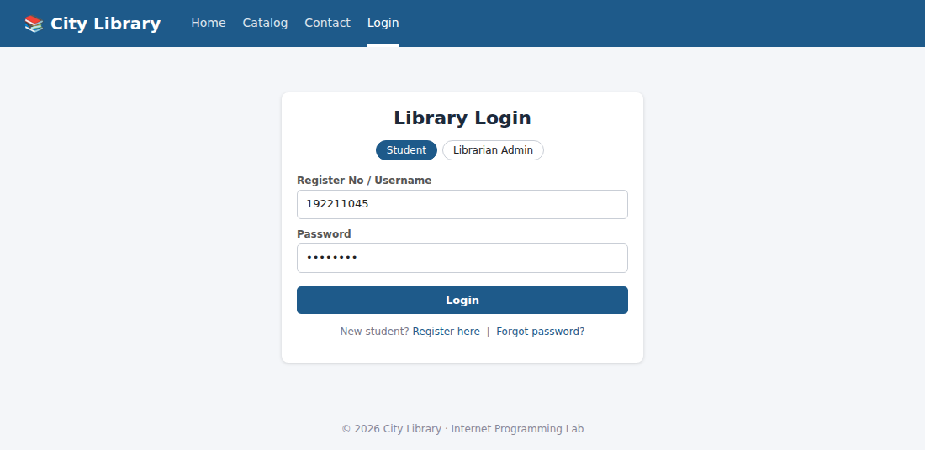
Figure 1: Login page (Librarian Admin / Student)
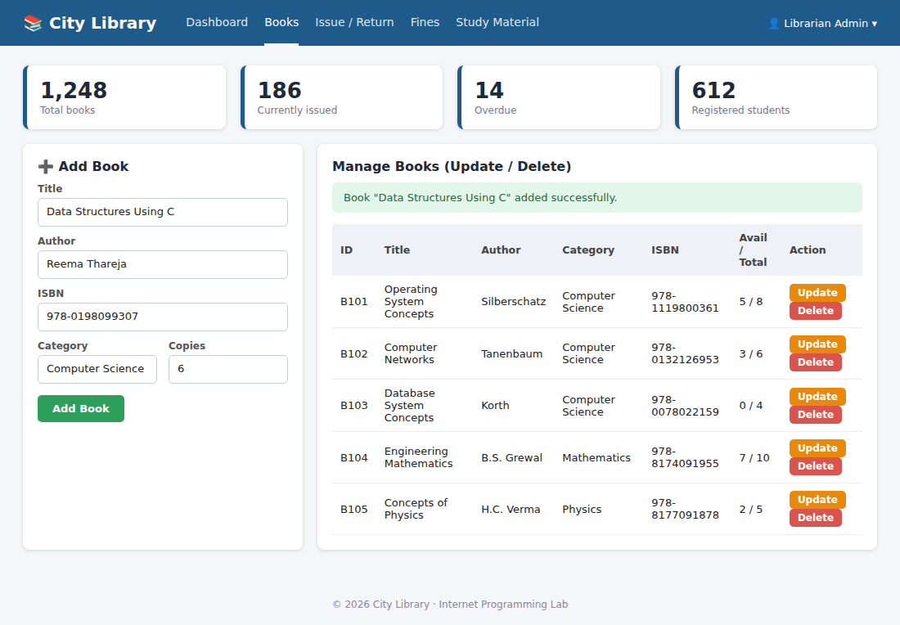
Figure 2: Admin – Add Book and Update / Delete Book
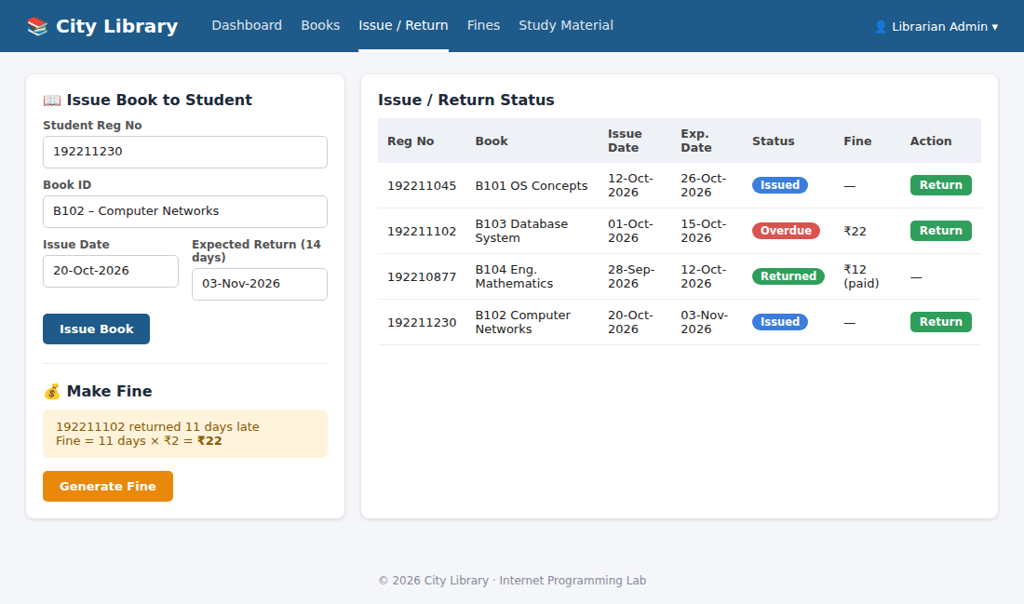
Figure 3: Admin – Issue Book for student, Return Book status and Make Fine
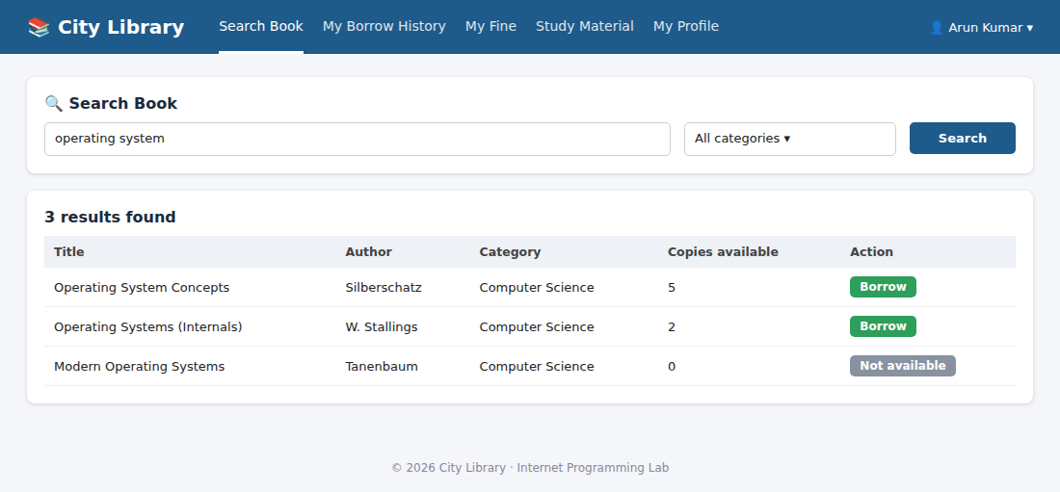
Figure 4: User – Search Book
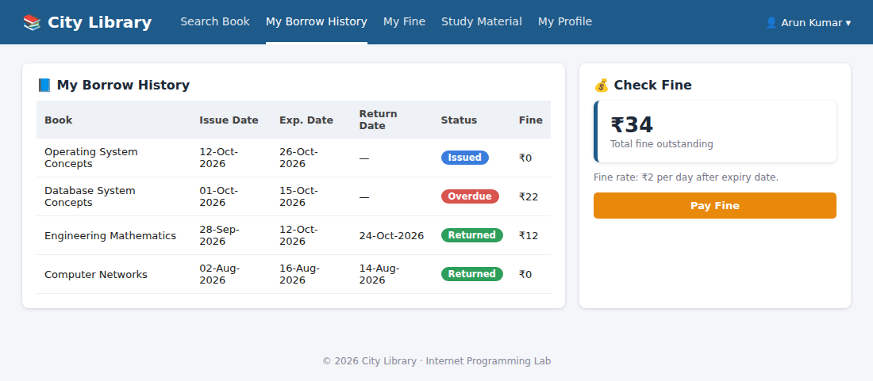
Figure 5: User – My Borrow History (Issue Date, Exp Date) and Check Fine
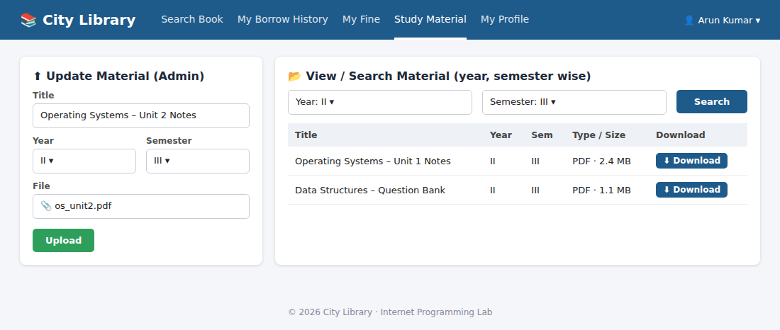
Figure 6: Admin – Update material; User – Search / Download material (year, semester wise)

Experiment 2: Online Hotel Room Booking

Question
The online hotel room booking website allows users to search for hotels based on destination, dates, and number of guests, offering detailed listings with room options, prices, amenities, and reviews. Users can create accounts, log in, and manage their bookings through a user-friendly dashboard. The booking process includes checking room availability, filling out a booking form, and completing secure payments via an integrated payment gateway. Post-booking, users receive confirmation emails and can leave reviews and ratings. Admins manage hotel listings, room availability, and user accounts through a dedicated admin panel. The website is fully responsive, ensuring seamless access on all devices.
Functionalities – Users:
- Users can register at the hotel and then they can view or modify their profile.
- Users can book a room on any specific date.
- Users can view all their booking history at the hotel.
- Users can change the booking at any time 3 days before the arrival date.
- Users can cancel the booking at any time 3 days before the arrival date.
- Users can check the room availability at the hotel before they book a room.
Administrator:
- Administrators can change the quantity and price of all four types of rooms.
- Administrators can change any specific booking details.
- Administrators can cancel any specific booking.
- Administrators can modify the details of static pages including room information, about us information, contact us information, customer service Q&A details, local travel and shipping guide, and privacy policy after login.
- It should also contain a basic room type introduction, contact information, customer service Q&A, local travel and shipping guide, and a privacy policy.

Output
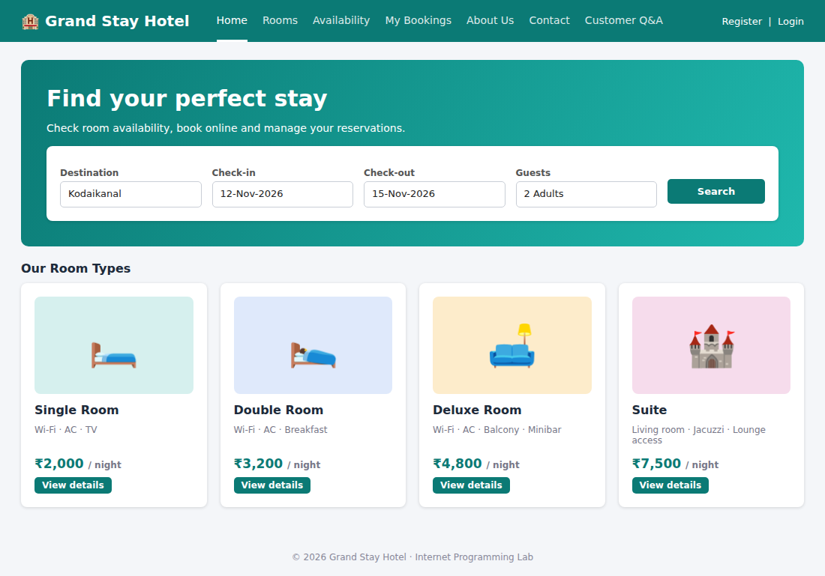
Figure 7: Home page – search by destination, dates and guests; room types
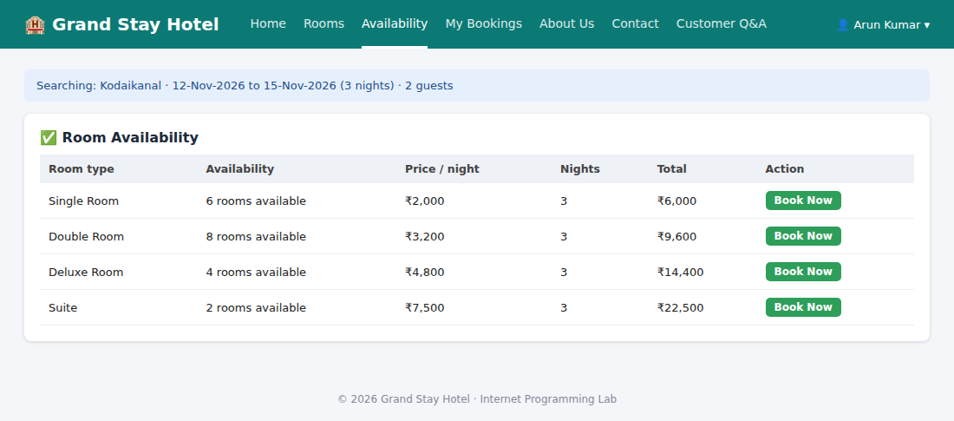
Figure 8: Check room availability
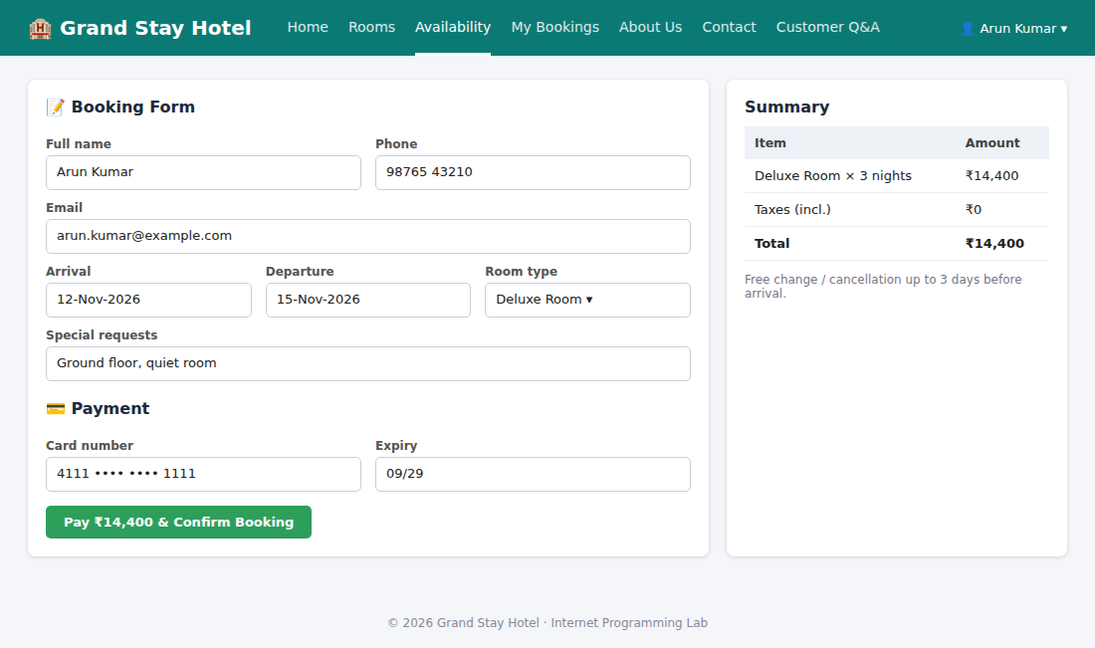
Figure 9: Booking form and payment
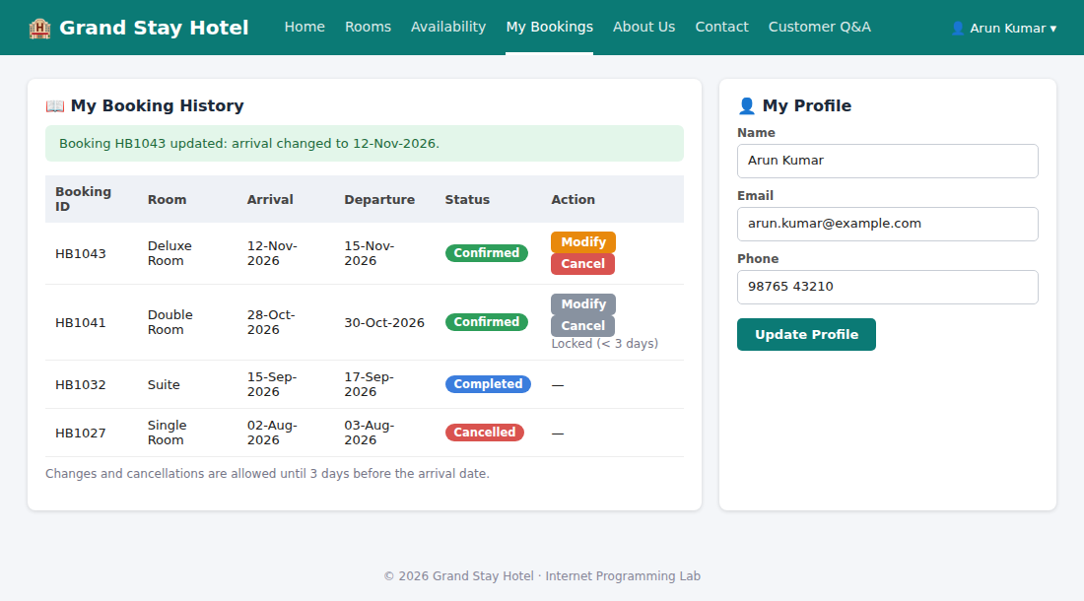
Figure 10: My booking history – change / cancel up to 3 days before arrival; My profile
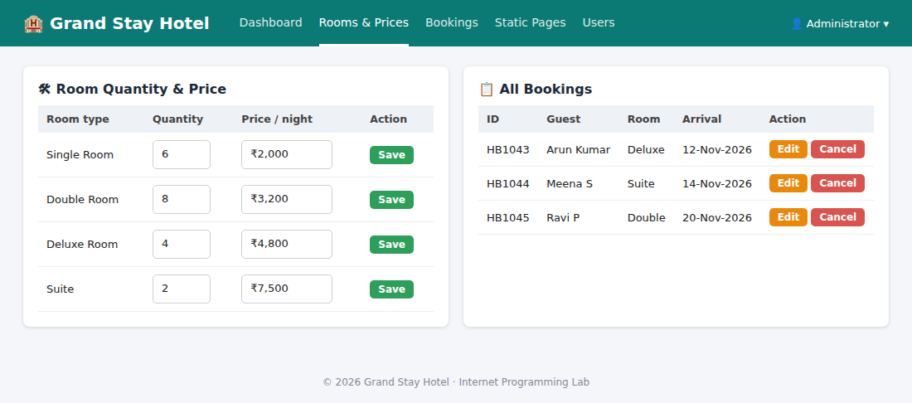
Figure 11: Admin – change quantity and price of the four room types; manage / cancel bookings
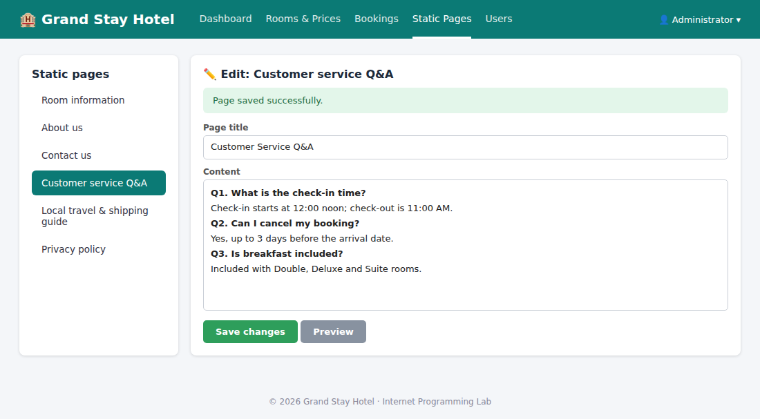
Figure 12: Admin – modify static pages (Customer service Q&A)

Experiment 3: Online Bus Ticket Booking System

Question
The online bus ticket booking system enables users to search for buses by route, date, and time, and view available seats. Users can create an account, log in, and manage their bookings through a personal dashboard. The booking process includes selecting seats, filling out passenger details, and making secure payments via an integrated payment gateway. Admins can manage bus schedules, seat availability, and user accounts through an admin panel. Users receive booking confirmation emails and can view their booking history. The website is mobile-responsive, ensuring easy access on all devices.
Admin: In this system, the admin can maintain all the Bus information and maintain Bus category, comments etc. The admin can maintain the registered users, manage news, and the admin can generate reports and manage the whole system.
Modules:
- Login: Login Module includes various utilities like User Authentication, Change Password and Forgot Password.
- Registration: Users can register on this website using the registration facility.
- Book the Ticket: The admin can add a new bus category using this module. Bus Category contains types like Volvo, Sleeper coach, coach etc.
- Update Bus Information: The admin can add or update a bus. It contains information about the bus type, photo, description, location of the tour, available seats in bus etc.
- Cancel the Booking Ticket: The user can cancel the booking ticket.
- Comments: Users can post comments on a particular bus.
- Report Generation: This module is used to generate a report.

Output
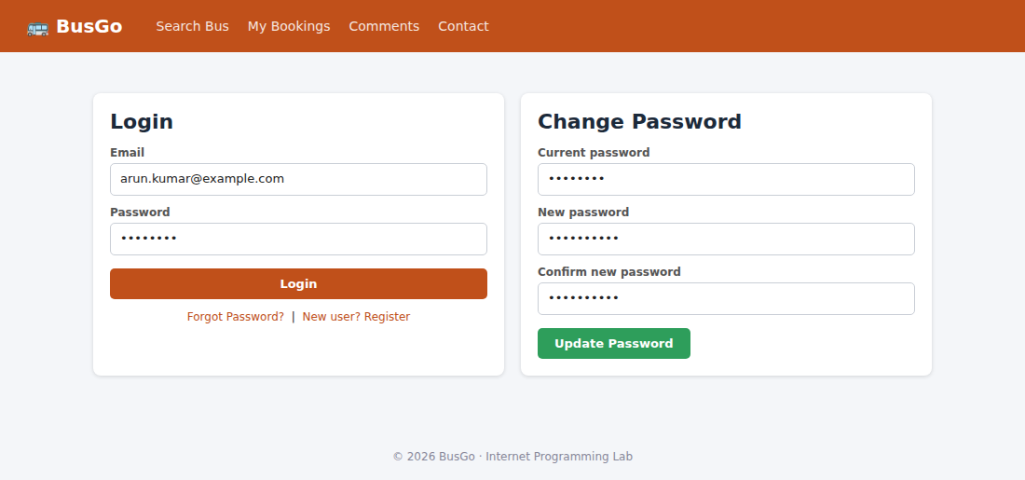
Figure 13: Login, Forgot Password and Change Password
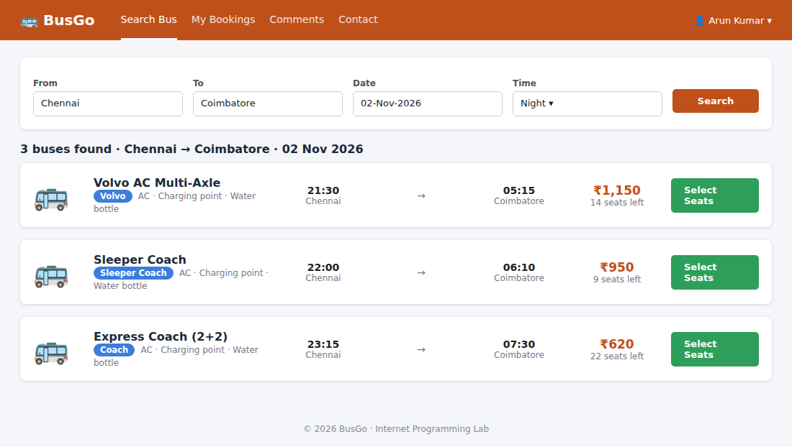
Figure 14: Search buses by route, date and time
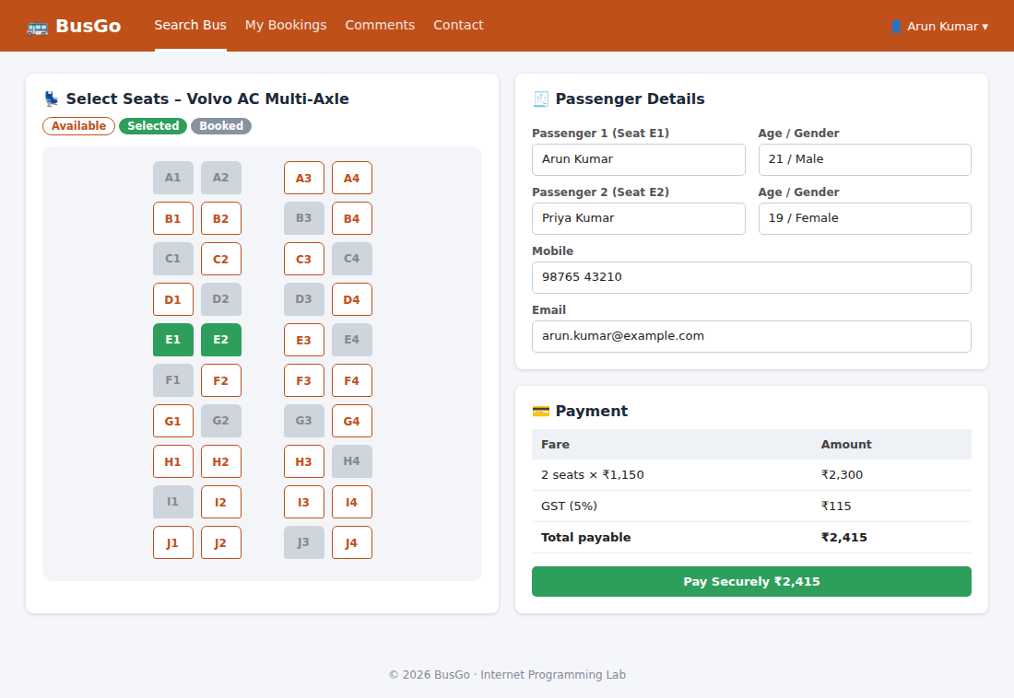
Figure 15: Seat selection, passenger details and payment
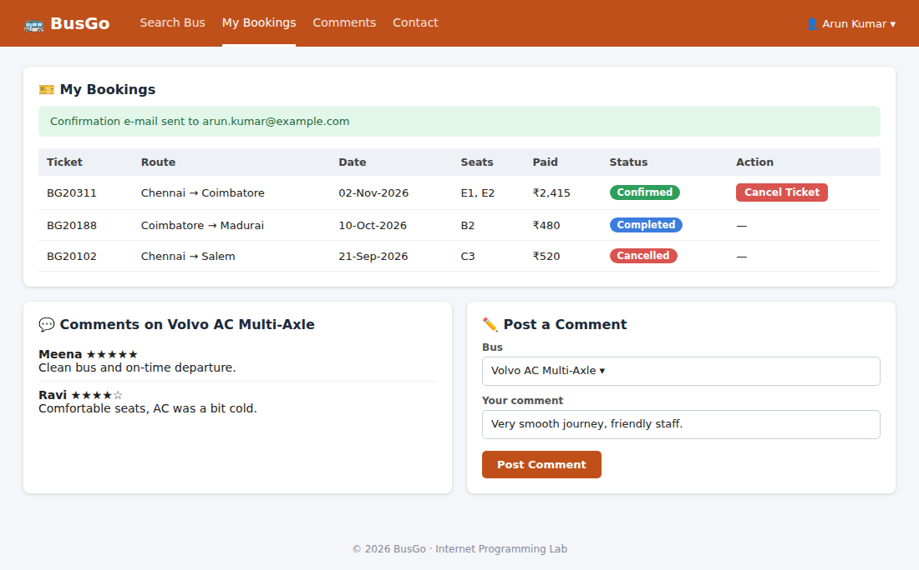
Figure 16: My bookings – cancel ticket; post comments on a bus
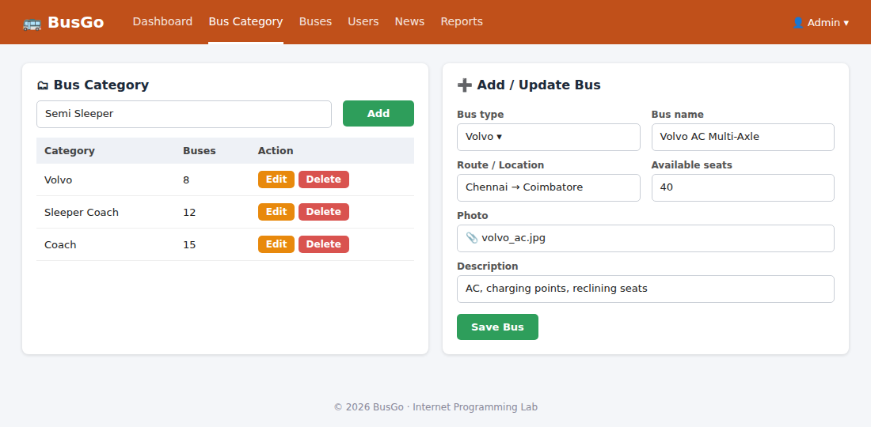
Figure 17: Admin – Bus category and Add / Update bus information
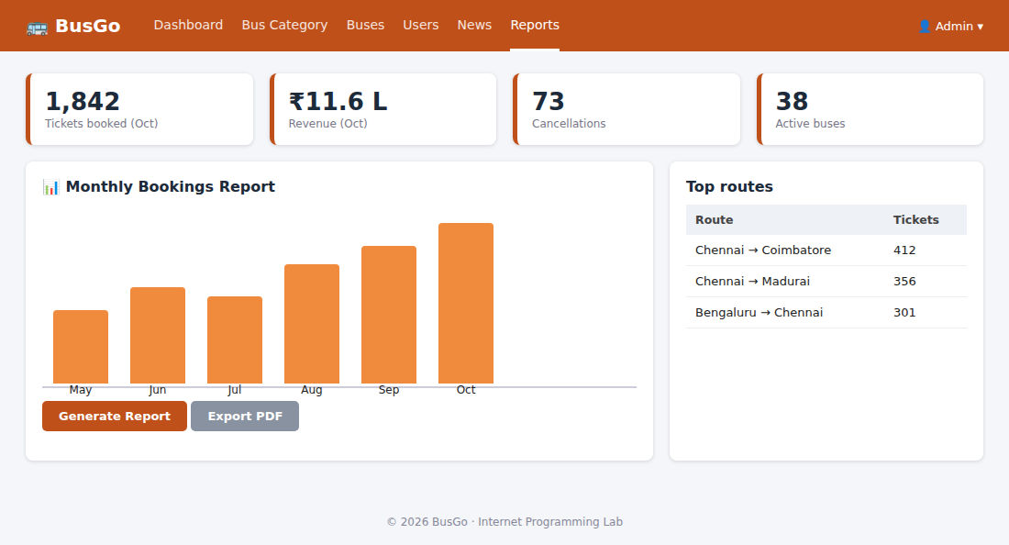
Figure 18: Admin – Report generation

Experiment 4: Online Train Reservation System

Question
The online train reservation system allows users to search for trains by route, date, and time, and view available seats and classes. Users can register, log in, and manage their reservations through a personal dashboard. The booking process involves selecting seats, entering passenger details, and making secure payments via an integrated payment gateway. Admins can manage train schedules, seat availability, and user accounts through a comprehensive admin panel. Users receive booking confirmation emails and can view their booking history and print tickets from their dashboard. The website features real-time seat availability updates and is fully responsive for seamless use on all devices.
The Reservation system should contain the following features:
- If a passenger wants to reserve ticket(s), firstly, he/she has to log in to the Railway system with valid credentials. Then, the passenger has to provide his/her details with the date of the journey, names of the passengers and their details, origin station details, destination station details, and the class type of the required ticket(s).
- The Railway Reservation System will provide the available Train-list, Seat availability, via-details.
- To book a ticket passengers can pay through online/offline mode. After successful payment of the ticket fare the System will generate the ticket and PNR no. will be given to the passenger. The System also keeps the payment details and sends them to the system Admin.
- The Passenger can check PNR status (confirmed, RAC, waiting list) by entering the PNR no. into the Reservation system.
- The Reservation system should store all train details, fare details (by zone, class, and date wise), PNR no, date of trains, etc. This maintenance should be controlled by the Admin.
- The System also has refund rules which have a date of reservation, ticket fare, and refundable percentage. The passenger can simply cancel the ticket(s) by entering the PNR no and a cancel ticket request. After cancellation, the admin will pass the refundable amount to the System and the System will give the refundable amount to the passenger.

Output
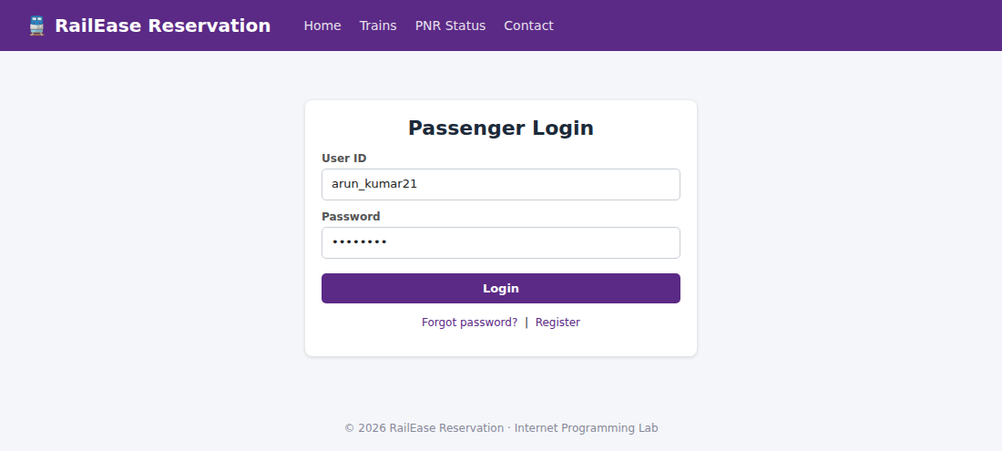
Figure 19: Passenger login
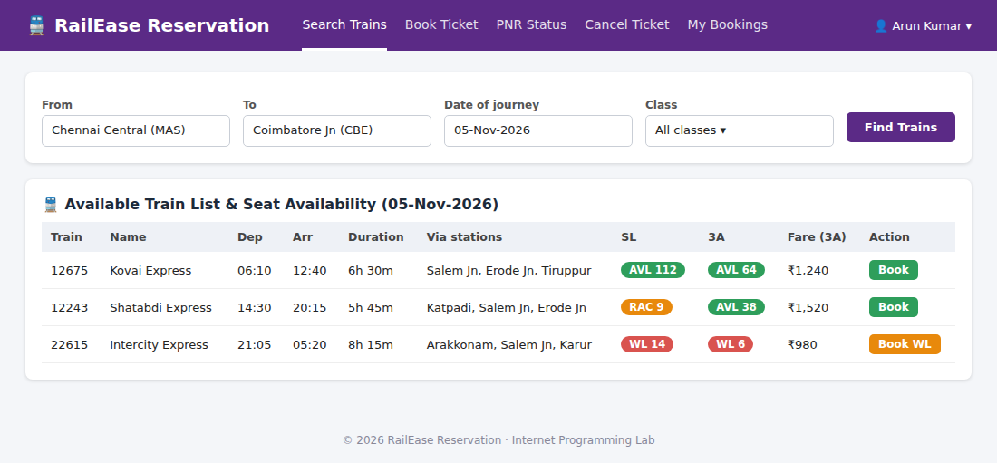
Figure 20: Available train list, seat availability and via-details
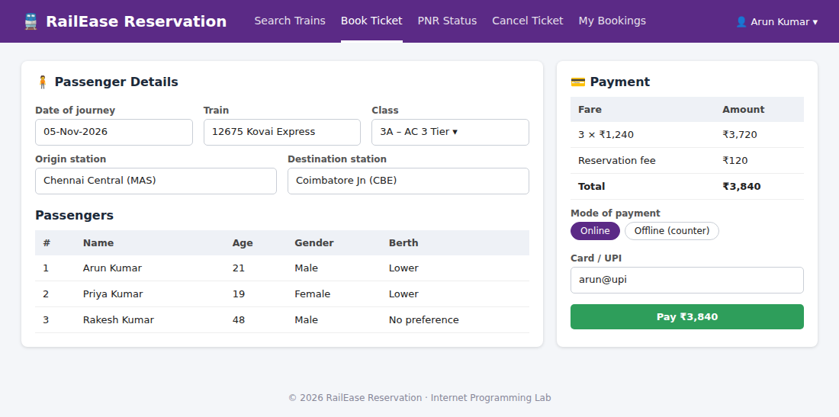
Figure 21: Passenger details and online / offline payment
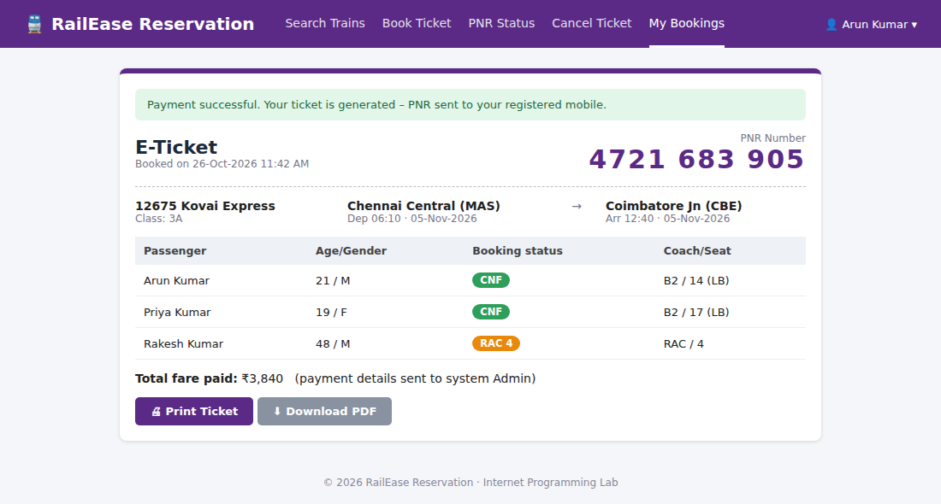
Figure 22: Generated ticket with PNR number
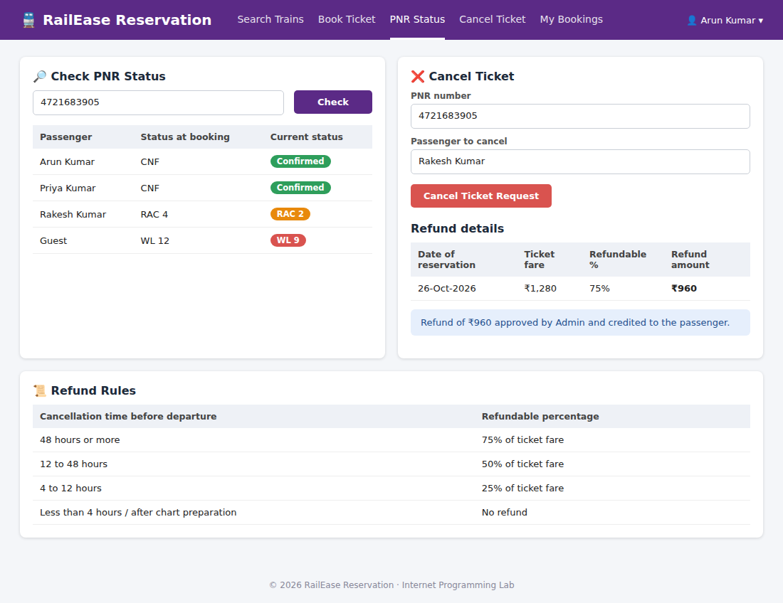
Figure 23: Check PNR status, cancel ticket and refund rules
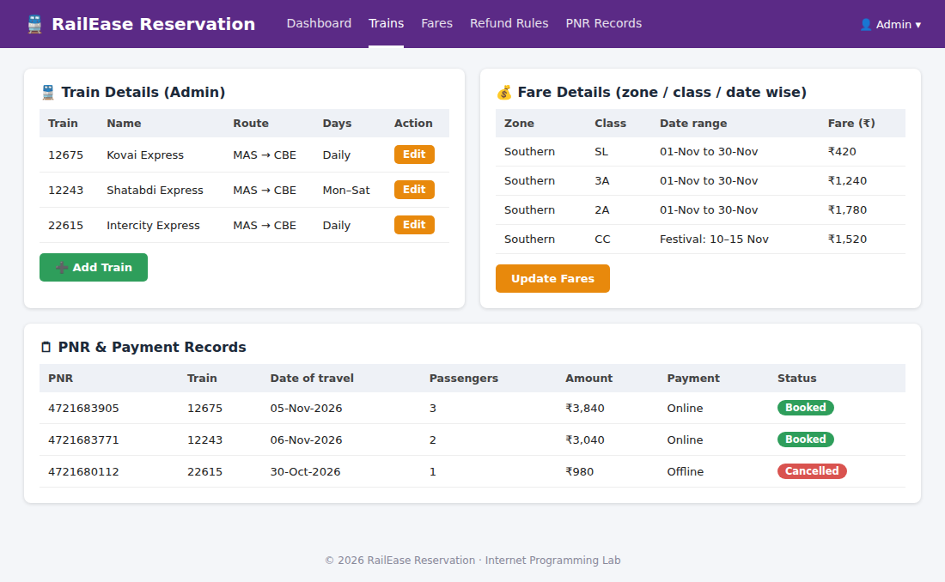
Figure 24: Admin – train details, fare details (zone / class / date wise) and PNR records

Experiment 5: Online Flight Reservation System

Question
The online flight reservation system enables users to search for flights by destination, date, and class, displaying available options with real-time seat availability. Users can register, log in, and manage their reservations via a personal dashboard. The booking process includes selecting flights, choosing seats, entering passenger details, and making secure payments through an integrated payment gateway. Admins can manage flight schedules, seat inventory, and user accounts using an advanced admin panel. Users receive booking confirmation emails with e-tickets and can view their booking history and travel itineraries. The website is fully responsive, ensuring an optimal experience on all devices. The airline reservation system is a web-based system that helps in consolidating flight data - flight schedules, seat availability, flight fares and reservations from all airlines with the help of global distribution systems and provides real-time inventory and rates for customers and travel agents to book flight tickets online.
Pages required:
- Administrator User Login Page
- Forgot Password Page
- Search Flight Page
- Book Ticket Page
- Ticket Payment Page
- My Ticket Page
- Cancel Ticket Page
- Customer Feedback
- Admin Report
- Search Flight Page
- View Booking Status Page
- Print Ticket Page

Output
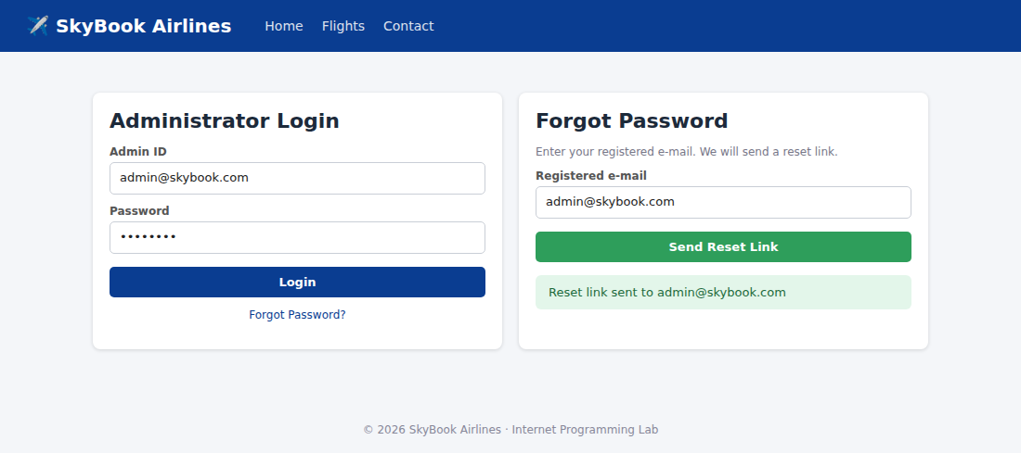
Figure 25: Administrator login and Forgot Password pages
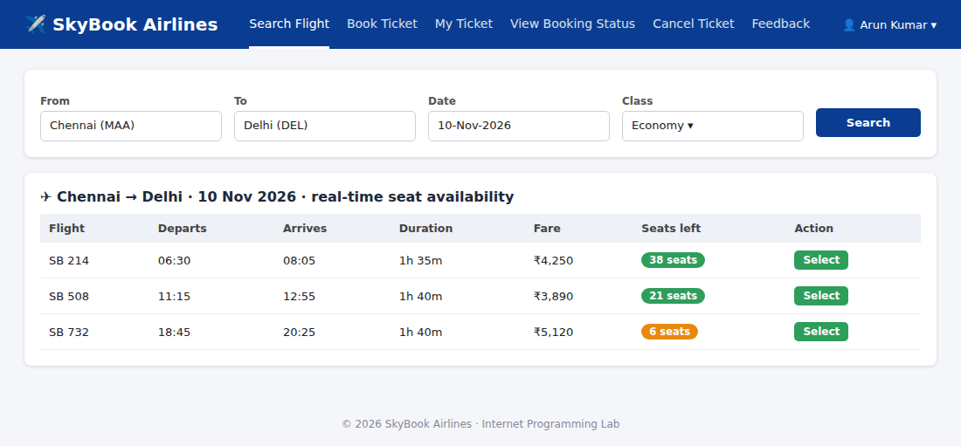
Figure 26: Search Flight page
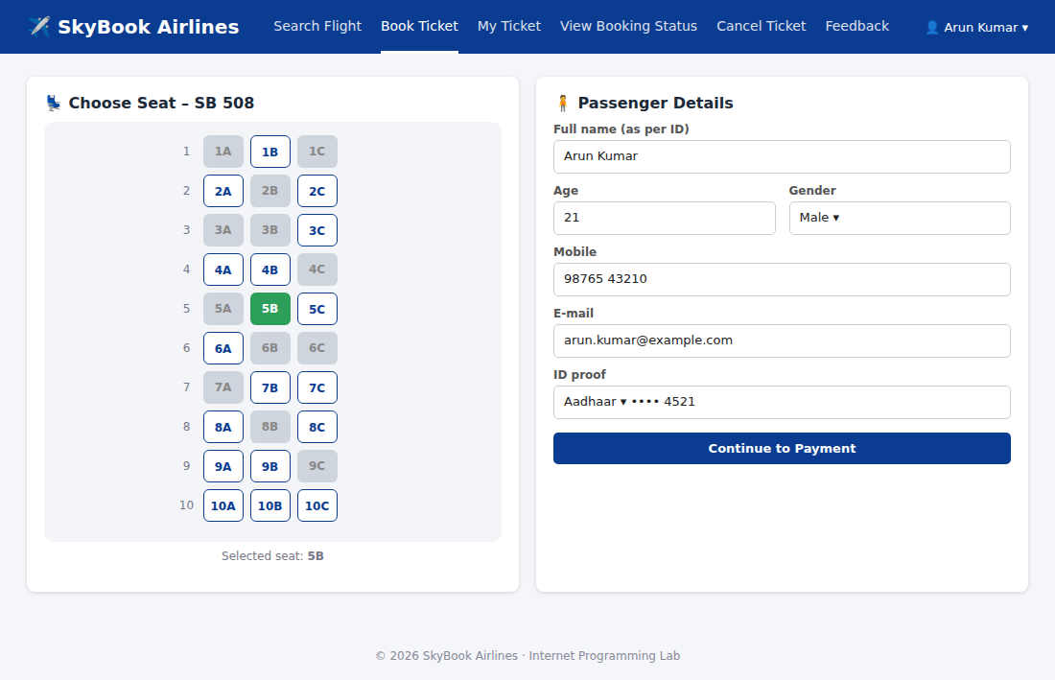
Figure 27: Book Ticket page – seat selection and passenger details
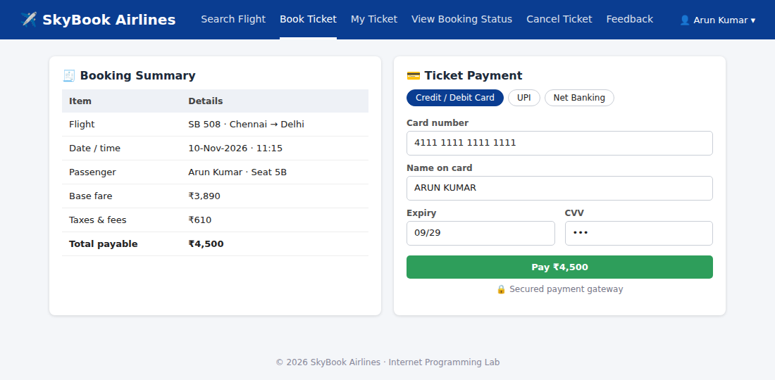
Figure 28: Ticket Payment page
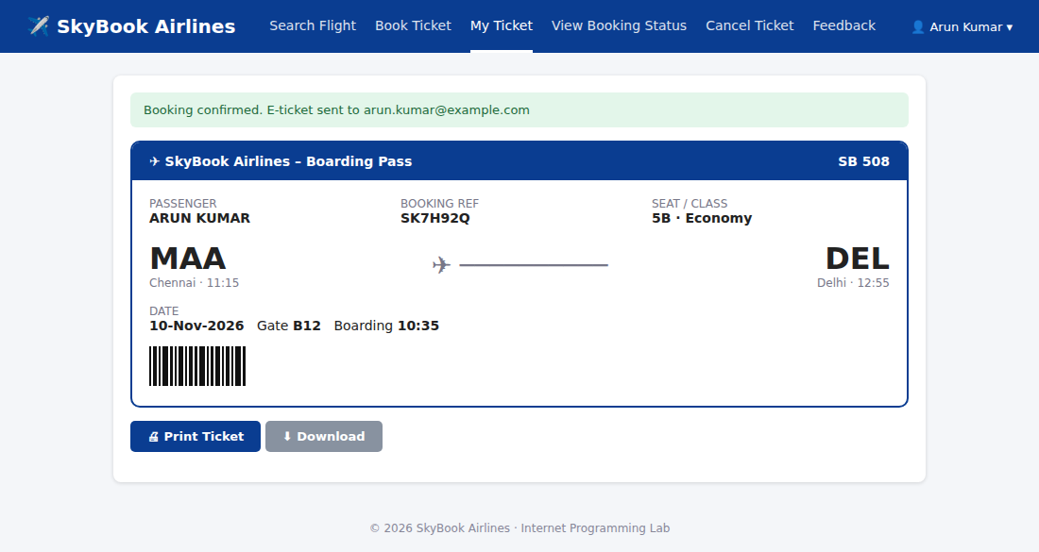
Figure 29: My Ticket / Print Ticket page
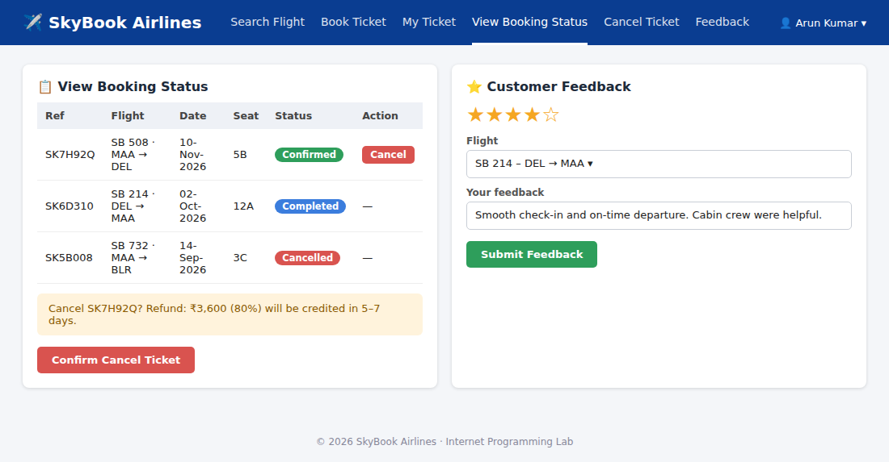
Figure 30: View Booking Status, Cancel Ticket and Customer Feedback
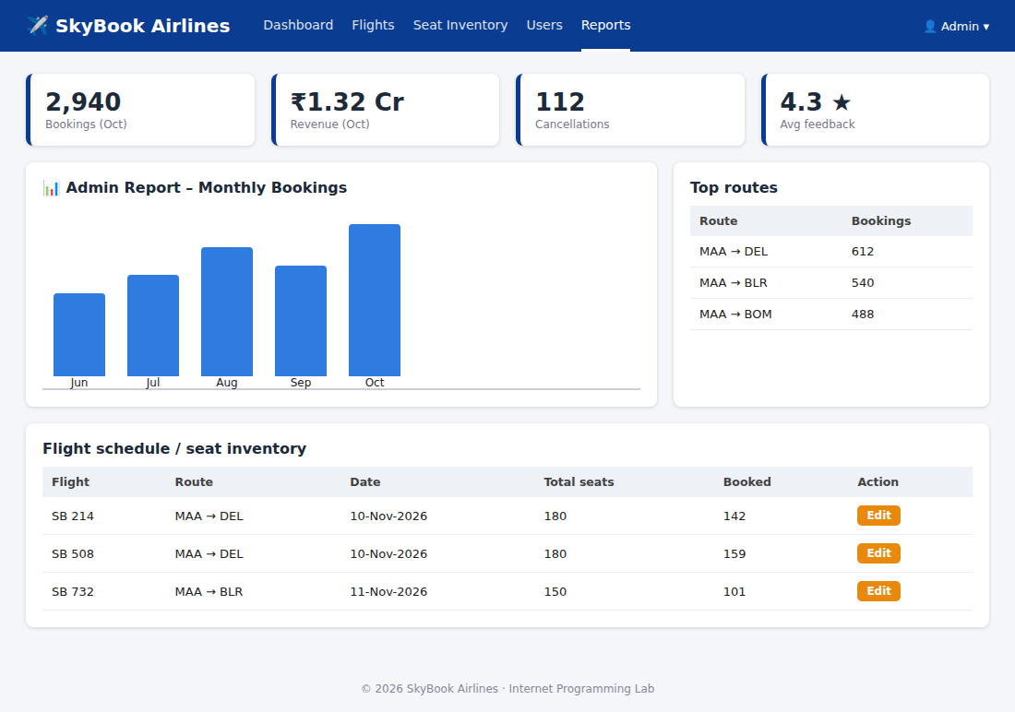
Figure 31: Admin Report

Experiment 6: Online Cake Ordering System

Question
The online cake ordering system allows users to browse a variety of cakes by category, flavor, and occasion, complete with detailed descriptions and images. Users can register, log in, and manage their orders through a personal dashboard. The ordering process includes selecting a cake, customizing options like size and message, entering delivery details, and making secure payments via an integrated payment gateway. Admins can manage cake inventory, track orders, and handle user accounts through an admin panel. Users receive order confirmation emails and can track delivery status. The website is fully responsive, providing a seamless shopping experience on all devices. Buy a Cake is a portal which allows admin in developing counters to advertise and sell their cake. This would permit rural communities to make their wares available to the rest of the world. The proposed system is to develop the website for cake store. User can buy the nearby cake available in app.
Admin:
- Login
- Manage Products
- Post Cake details
- Upload images
- Product
- Description
- Manage Orders
- Update order Status
- Shipping Location
- Logout
Student (User):
- Register
- Login
- Search Cake
- Filter
- Category
- Sub category
- Price Range
- View Cake list
- View cake description
- Add to Cart
- Place order
- Add Shipping Address
- Update Shipping Address
- My Order
- View Shipping Status

Output
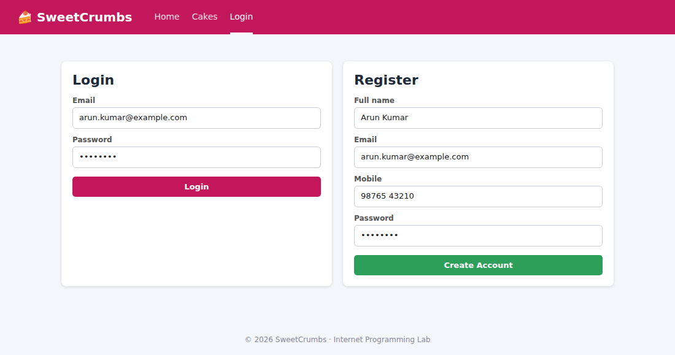
Figure 32: User Register and Login
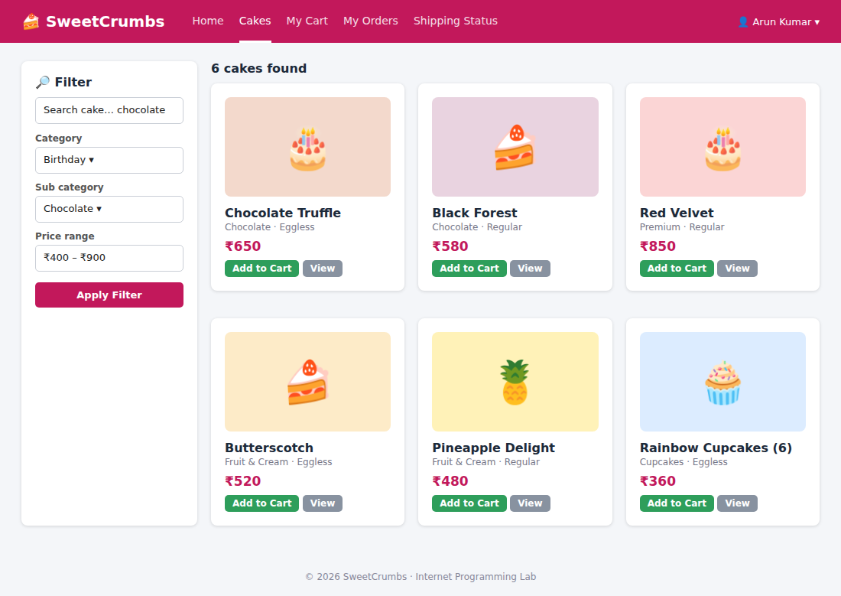
Figure 33: Search, filter (category, sub category, price range) and cake list
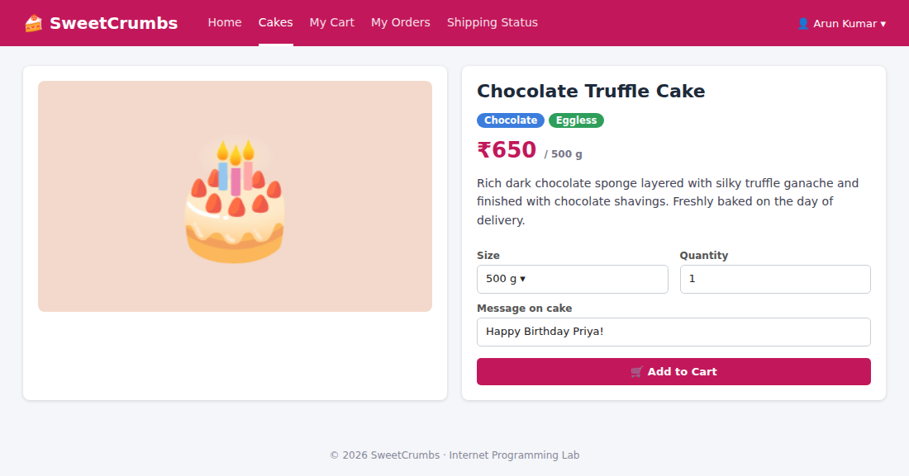
Figure 34: View cake description
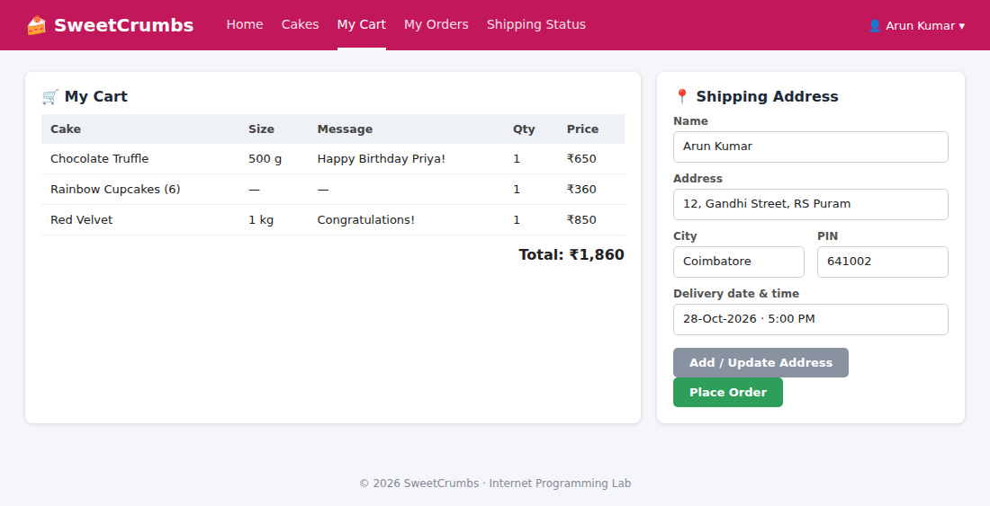
Figure 35: Add to cart, shipping address and place order
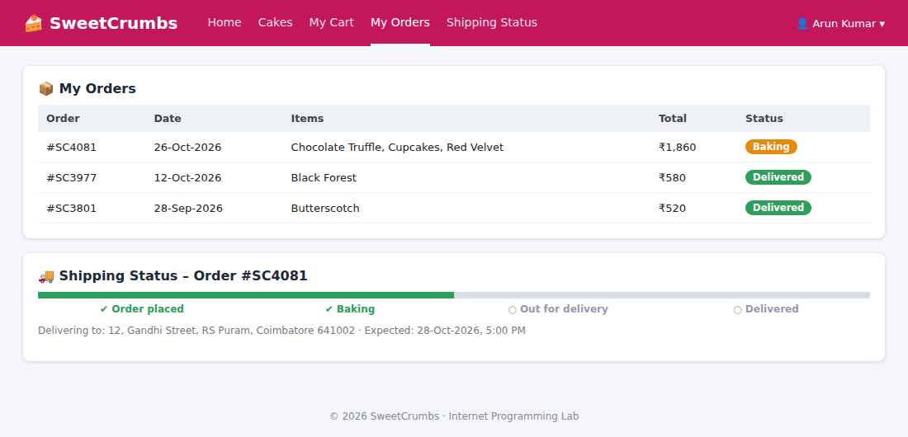
Figure 36: My Orders and View Shipping Status
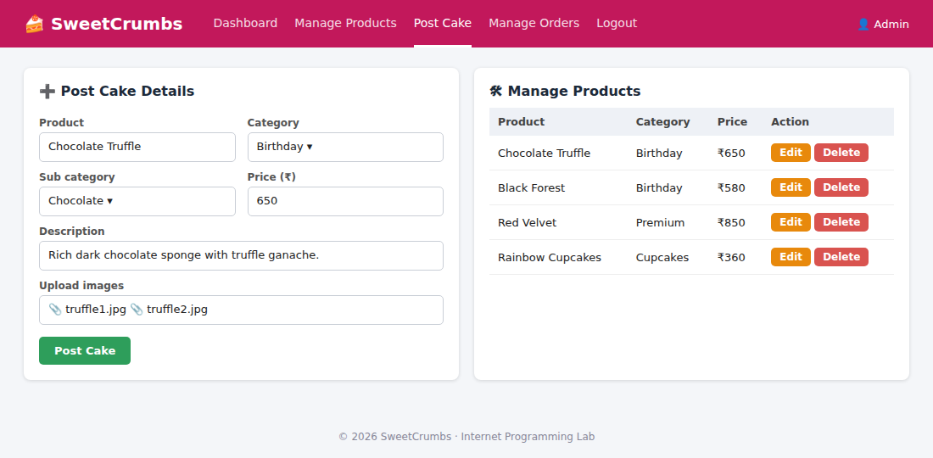
Figure 37: Admin – Post cake details, upload images and manage products
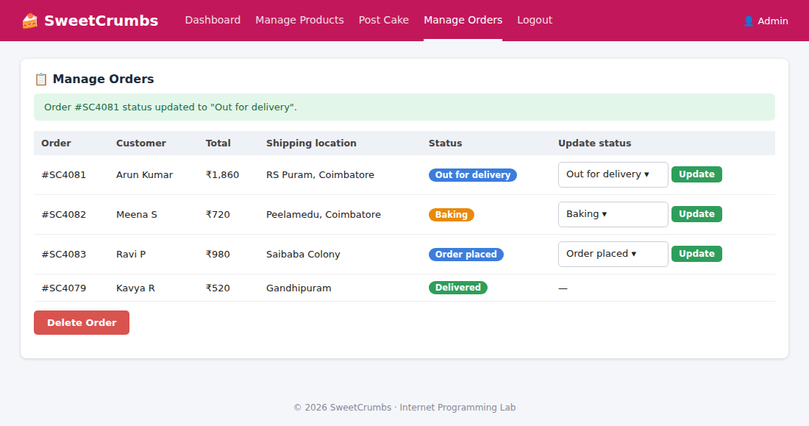
Figure 38: Admin – Manage orders, update order status and shipping location

Experiment 7: Online Beauty Parlour Appointment Booking

Question
The online beauty parlour appointment booking system allows users to browse available services, view stylist profiles, and check appointment slots in real-time. Users can register, log in, and manage their appointments through a personal dashboard. The booking process includes selecting services, choosing a stylist, selecting a date and time, and making secure payments via an integrated payment gateway. Admins can manage service offerings, stylist schedules, and user accounts through a comprehensive admin panel. Users receive appointment confirmation emails and reminders, with the option to reschedule or cancel appointments through their dashboard. The website is fully responsive, ensuring an optimal experience on all devices. This website helps customers to search for any beauty parlour and book appointments as they preferable date and time.
Reservations:
- Have reservations calendar
- Create, edit, and cancel reservations
- Lockout unavailable hours
- Get the crucial information for each date on the calendar
Customers' personal account page:
- Upcoming reservations
- Reservations history
- Personal data
Salon manager and staff member (control and manage reservations):
- Upcoming reservations
- Reservations calendar
- Add reservation
- Edit reservations
- Send an SMS or call to the customer
- Customers leave feedback about their experiences and learn from their suggestions
Payments:
- Accept online payments as a whole payment or as a partial deposit with Stripe or PayPal or with one of the available payments
- Require full payment or a deposit
- Accept PayPal or Stripe
- Automatic cancellation of unpaid reservations
- More than twenty different payment platform integration add-ons

Output
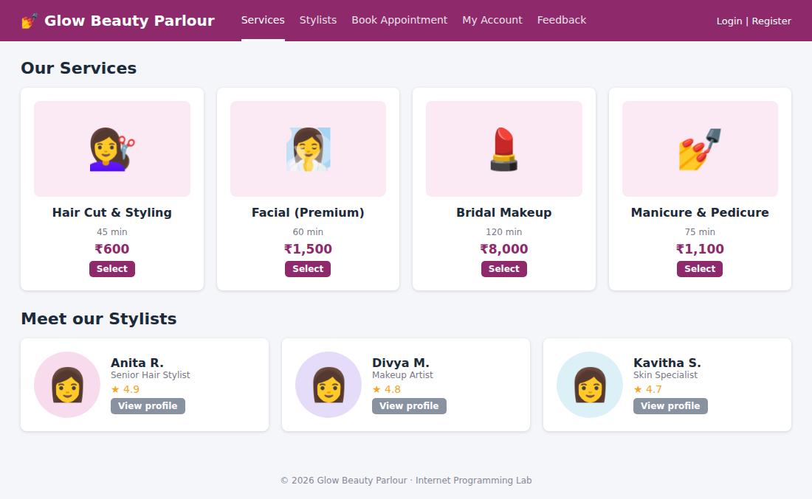
Figure 39: Browse services and stylist profiles
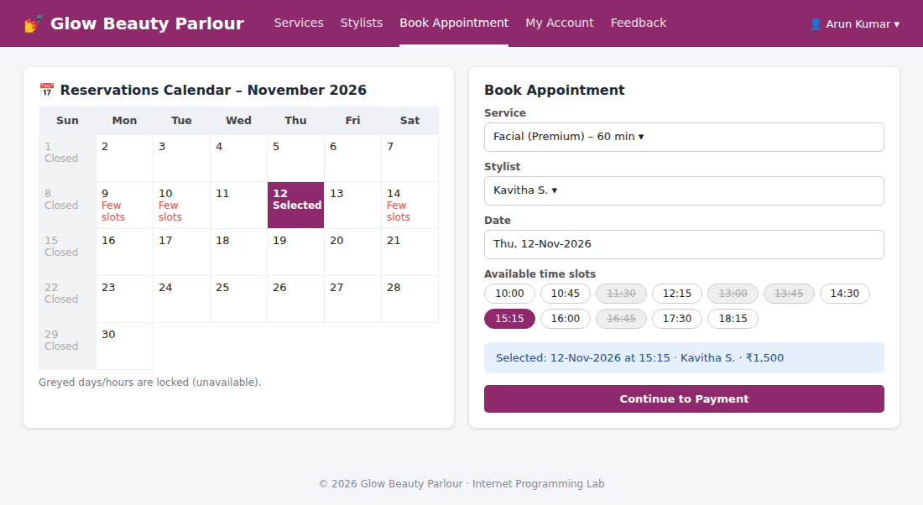
Figure 40: Reservations calendar with locked (unavailable) hours and appointment booking
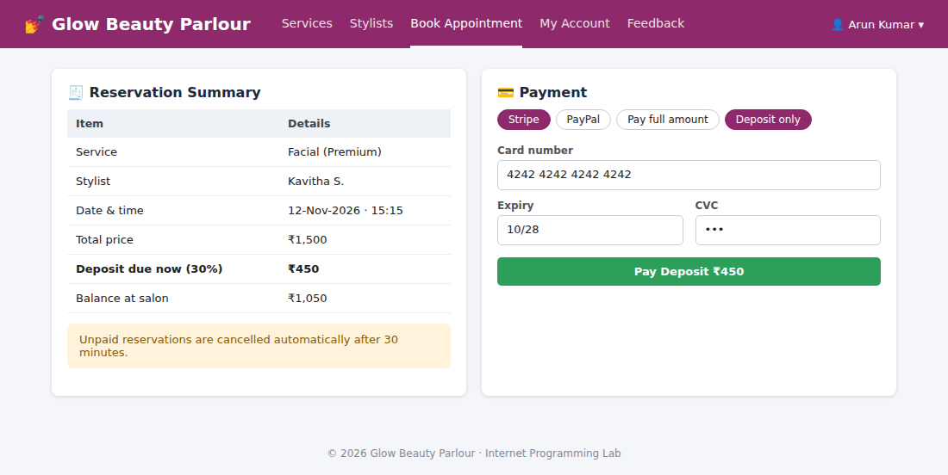
Figure 41: Online payment – full payment or deposit (Stripe / PayPal)
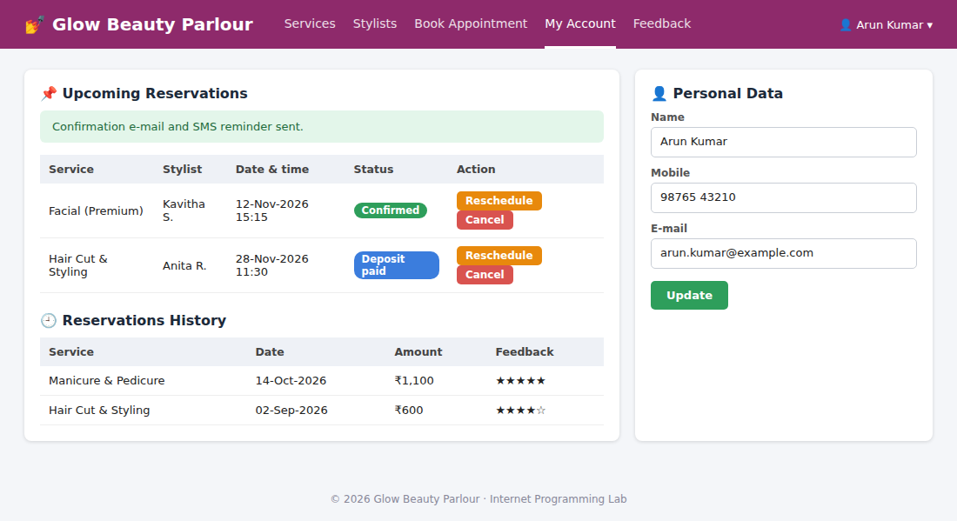
Figure 42: Customer account – upcoming reservations, history and personal data
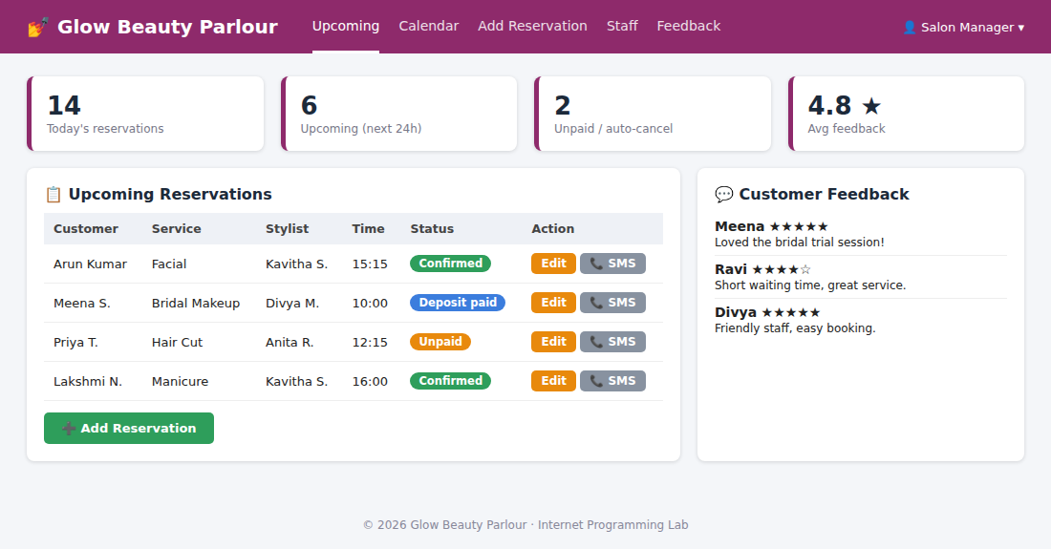
Figure 43: Salon manager – upcoming reservations, add / edit, SMS to customer and feedback

Experiment 8: Hospital Appointment Booking (MedCare)

Question
In an effort to streamline the appointment process and enhance patient experience, MedCare Hospital has developed an online appointment booking system. This platform allows patients to book appointments with doctors from various specialties at their convenience. Key functionalities include user registration and login, browsing available doctors and appointment slots, booking and canceling appointments, and receiving appointment reminders via email or SMS. Patients can also view their appointment history and update their personal details. The system ensures data security and compliance with healthcare regulations to protect patient information. This online service aims to reduce wait times, minimize paperwork, and provide a seamless experience for patients and healthcare providers alike. This website helps the patient to search any hospital and book appointments as they prefer.
Modules:
- Search Module
- Appointment Booking
- Check-in form Submitting
- Appointment management
- Schedule a timing
- Past appointment Management
Admin Features:
- Manage appointments
- Manage doctors
- View Appointments statistics
- Rating Details
Patient Features:
- Signup/Login
- Can choose and book an appointment at the flexible time and date
- Can search for doctor according to specialty and location
- Can write reviews about the doctor and can select doctors according to other user feedback
- Can access all previous check-in details and medical past appointment
User:
- User Registration
- User Login
- Search Location wise
- View Hospital list
- Book Appointment
- View status
- View google map for single hospital
Hospital:
- Hospital Registration
- Hospital login
- Create hospital details
- Update details
- Update location

Output
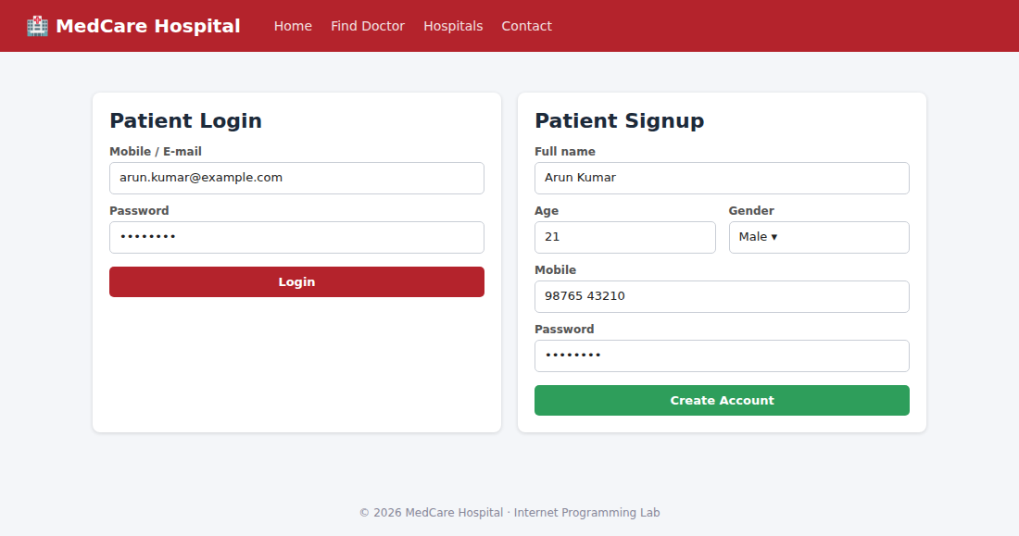
Figure 44: Patient signup and login
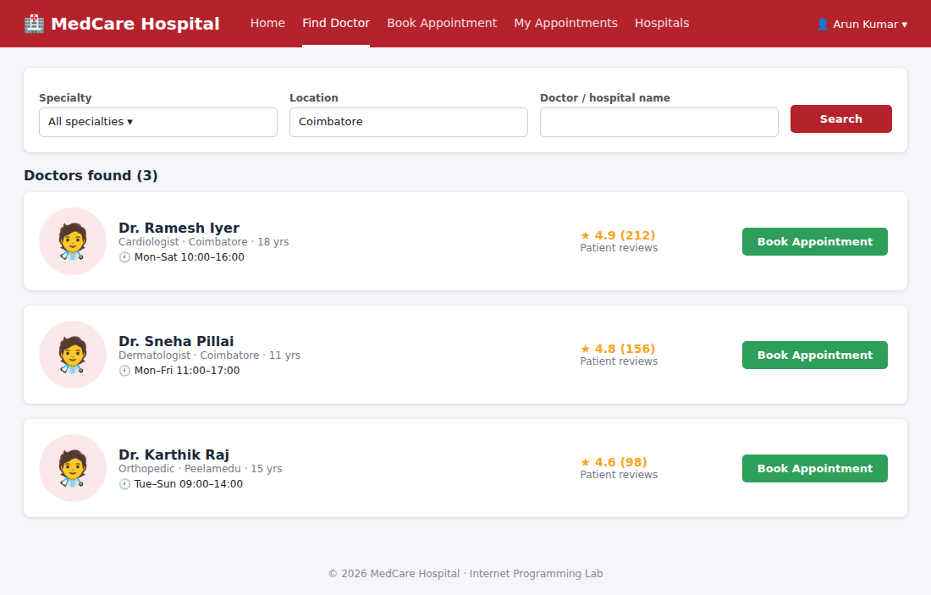
Figure 45: Search doctor by specialty and location
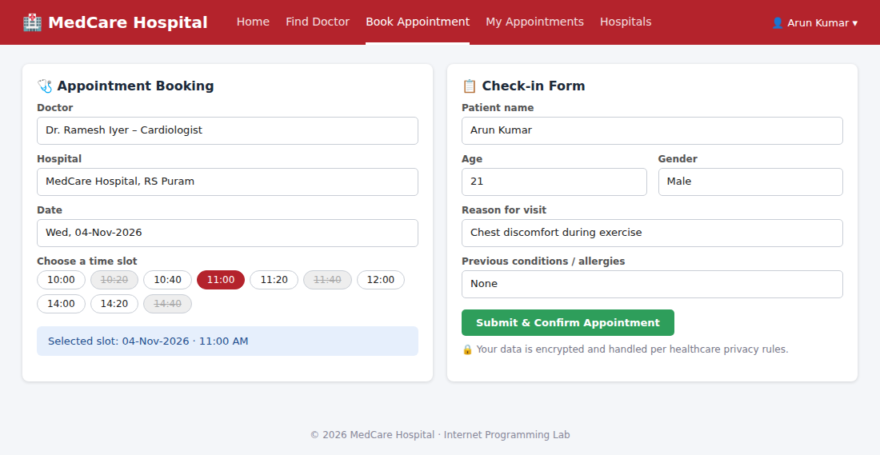
Figure 46: Appointment booking and check-in form
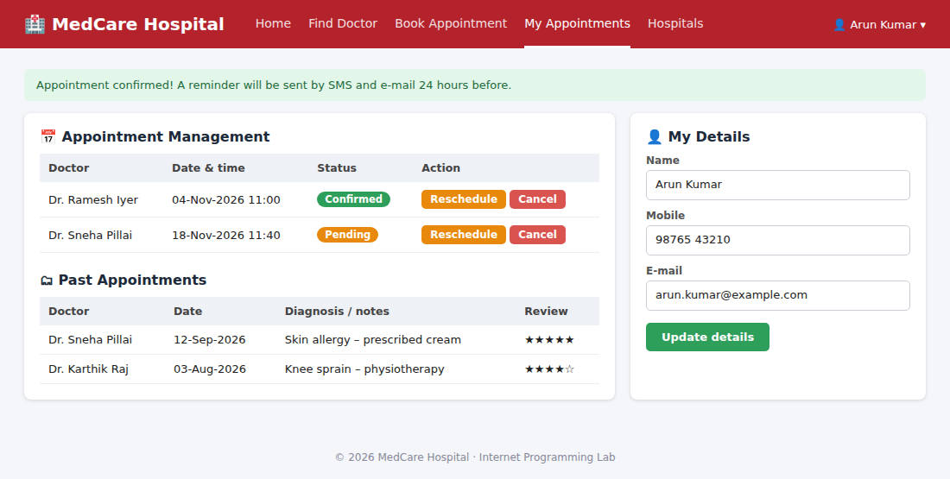
Figure 47: Appointment management and past appointments
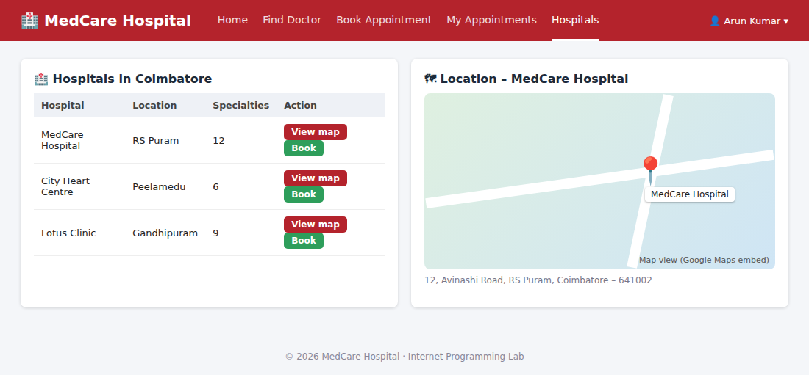
Figure 48: Hospital list and Google map for a hospital
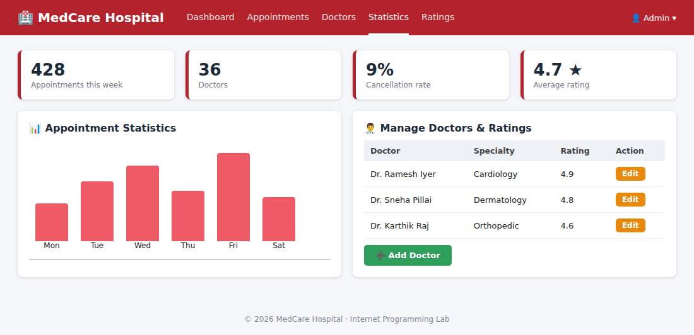
Figure 49: Admin – appointment statistics, manage doctors and ratings

Experiment 9: Online Electronics Shopping Platform (TechSavvy)

Question
TechSavvy, a leading retailer of electronic gadgets, has launched an online shopping platform to provide customers with a seamless and convenient shopping experience. The website features a wide range of products, including smartphones, laptops, tablets, and accessories, all categorized for easy browsing. Key functionalities include user registration and login, product search and filtering, detailed product descriptions and reviews, secure payment options, and order tracking. Customers can add items to their cart, create wish lists, and receive personalized recommendations based on their browsing and purchase history. The platform also offers exclusive online discounts and promotions, ensuring customers get the best deals on the latest gadgets. The core of an online shop is the product catalogue and the cart. The users browse products which are grouped in categories and add the desired ones to the cart. Next, there is transaction handling, which in its simplest form consists in the order being sent via e-mail to the seller, but most often it takes the whole buying process through separate order statuses.
Requirements:
- Products should be logically categorized, with the most popular categories listed first. Display all the available categories for shopping on the home page.
- Display all the subcategories on the home page, that are associated with any particular item.
- Admin has the authority to add new particulars to the items list whenever needed.
- Permission to the administrator to remove items, anytime.
- Allows the admin to modify the price of each item, whenever required or felt like.
- Admin has the authority to update the description of each item.
- Permission to the admin to view information about each customer who checkouts the items list.
Use Cases:
- Visit a site
- Login
- Search for Items
- Check Availability of Items
- Add Items to Shopping Cart
- Edit Items in the Shopping Cart
- Remove Items from the Shopping Cart
- Check out the Shopping Cart
- Check Order Status
- Browse Order History
- Display Item Details
- Logout
- Leave a site

Output
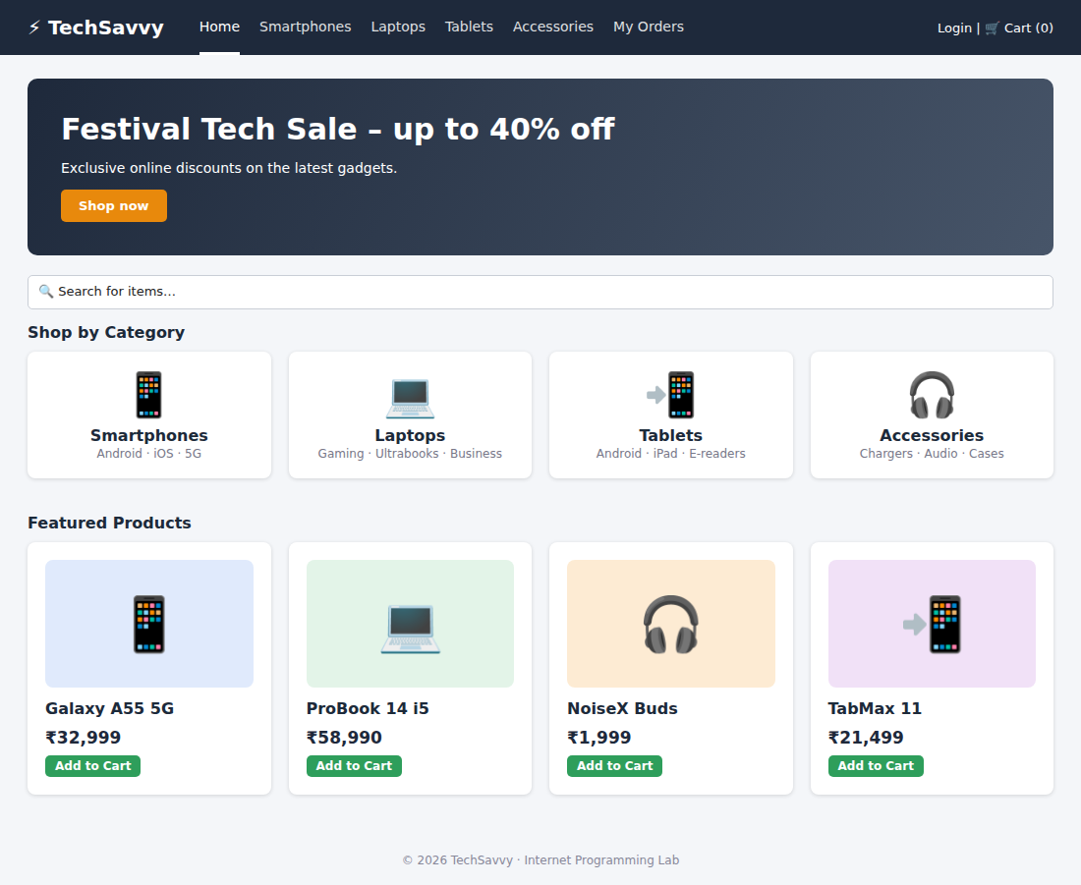
Figure 50: Home page – categories, sub-categories and featured products
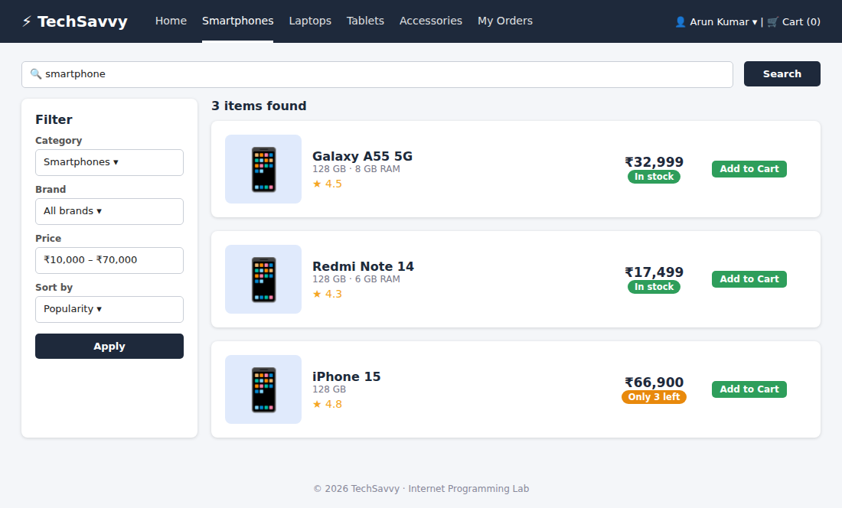
Figure 51: Search for items with filters
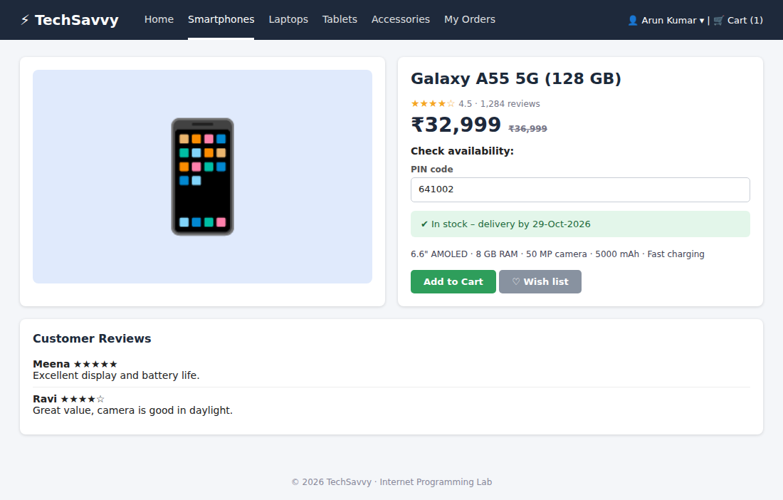
Figure 52: Display item details and check availability
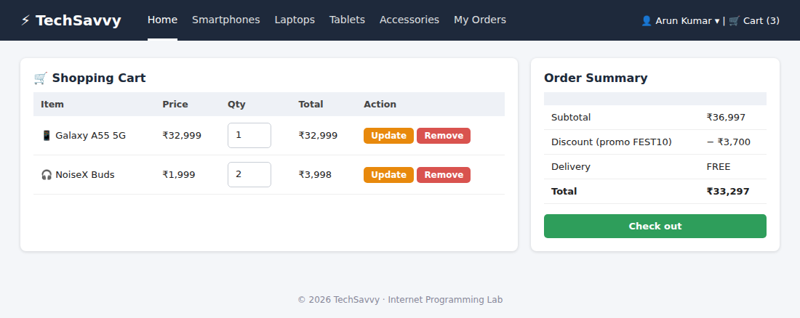
Figure 53: Shopping cart – edit / remove items
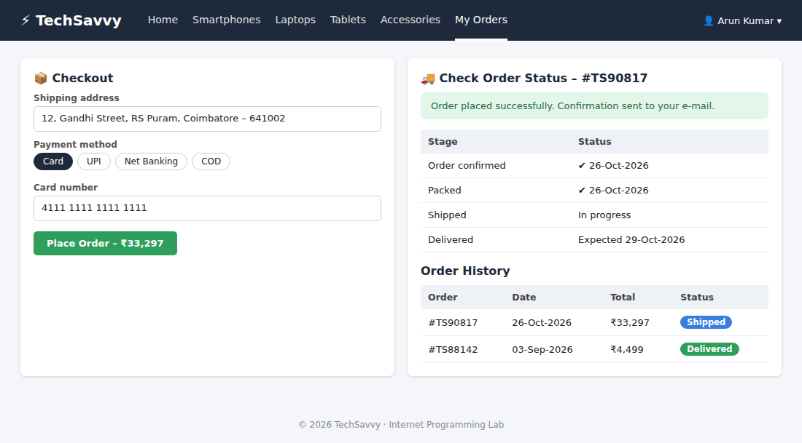
Figure 54: Check out, check order status and order history
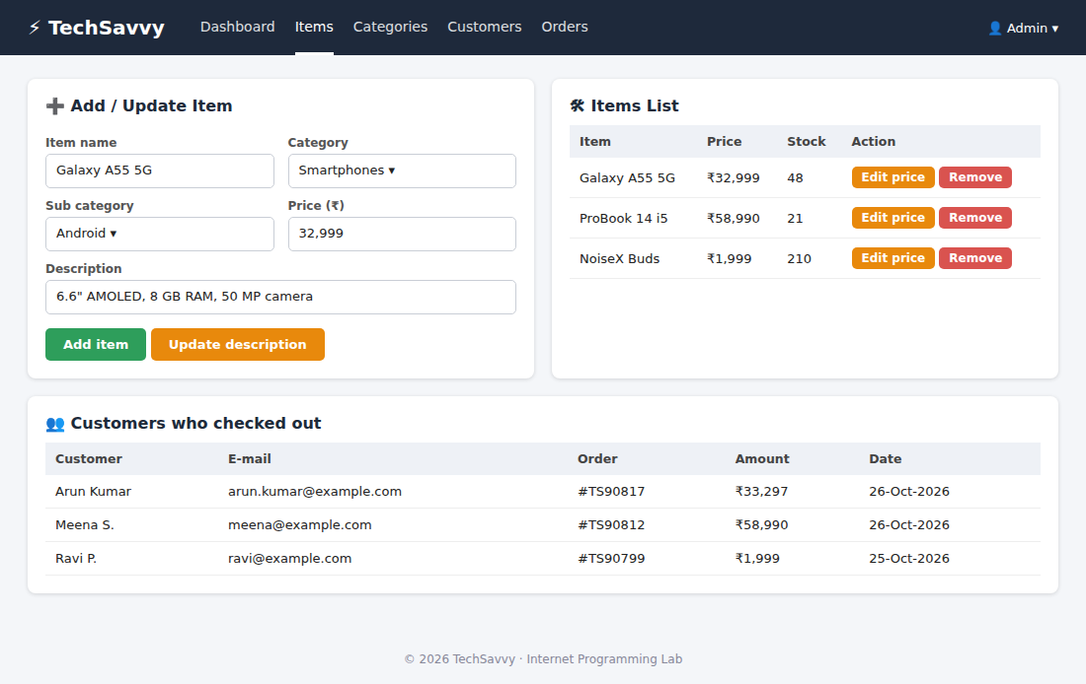
Figure 55: Admin – add / remove items, modify price and description, view customers

Experiment 10: Online Fashion Store (StyleHub)

Question
StyleHub, a premier online fashion retailer, introduces its comprehensive e-commerce platform designed to cater to fashion enthusiasts. The website offers an extensive collection of clothing, footwear, and accessories for men, women, and children, with categories such as casual wear, formal attire, and seasonal collections. Key functionalities include user registration and login, advanced search and filtering options, detailed product descriptions with high-resolution images, customer reviews, and size guides. The platform supports secure payment methods, order tracking, and an easy return and exchange policy. Customers can create wish lists, receive personalized style recommendations, and enjoy exclusive online discounts and flash sales. StyleHub aims to provide a seamless and enjoyable shopping experience, keeping users up-to-date with the latest fashion trends. The core of an online shop is the product catalogue and the cart. The users browse products which are grouped in categories and add the desired ones to the cart. Next, there is transaction handling, which in its simplest form consists in the order being sent via e-mail to the seller, but most often it takes the whole buying process through separate order statuses.
Requirements:
- The key to helping customers find the products they need quickly is to offer a user-friendly navigation system.
- Products should be logically categorized, with the most popular categories listed first.
- Display all the available categories for shopping on the home page.
- Display all the subcategories on the home page, that are associated with any particular item.
- Admin has the authority to add new particulars to the items list whenever needed.
- Permission to the administrator to remove items, anytime.
- Allows the admin to modify the price of each item, whenever required or felt like.
- Admin has the authority to update the description of each item.
- Permission to the admin to view information about each customer who checkouts the items list.
Use Cases:
- Visit a site
- Login
- Search for Items
- Check Availability of Items
- Add Items to Shopping Cart
- Edit Items in the Shopping Cart
- Remove Items from the Shopping Cart
- Check out the Shopping Cart
- Check Order Status
- Browse Order History
- Display Item Details
- Logout
- Leave a site

Output
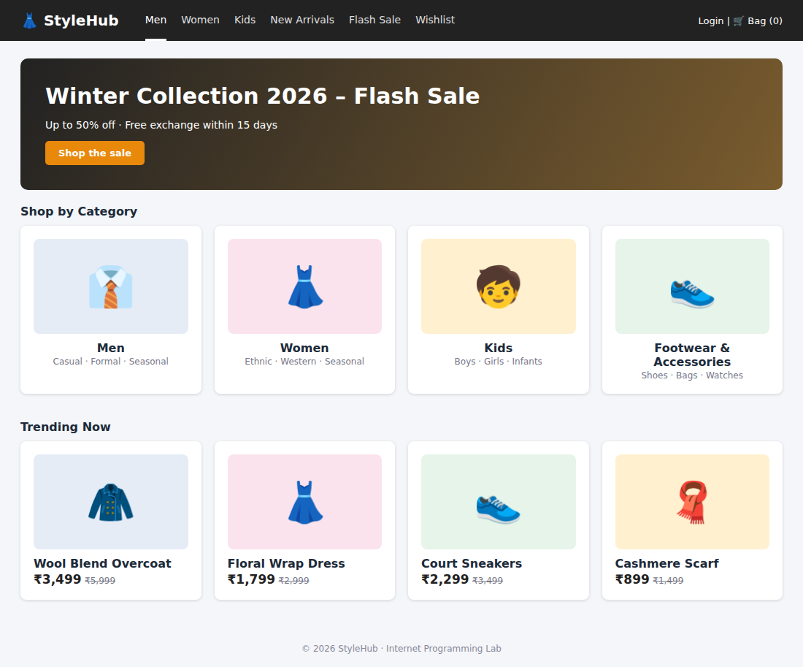
Figure 56: Home page – categories for men, women and kids; flash sale
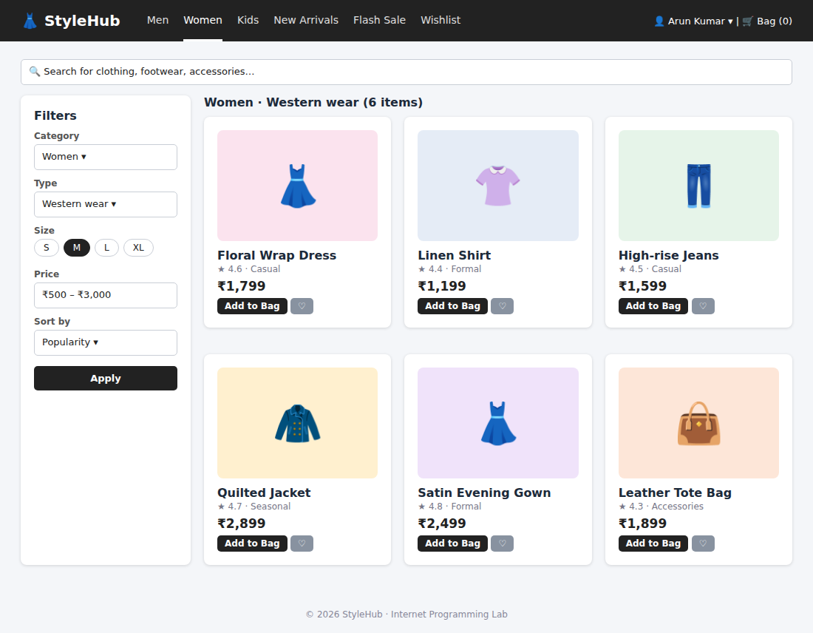
Figure 57: Advanced search and filtering
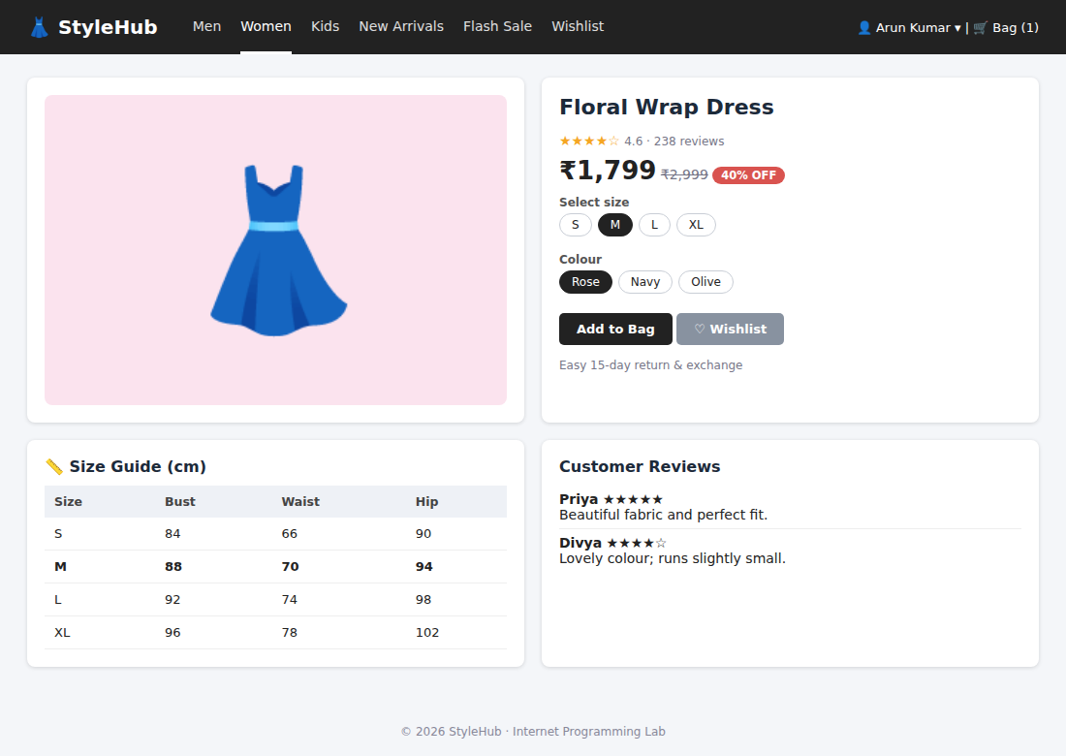
Figure 58: Product details with size guide and reviews
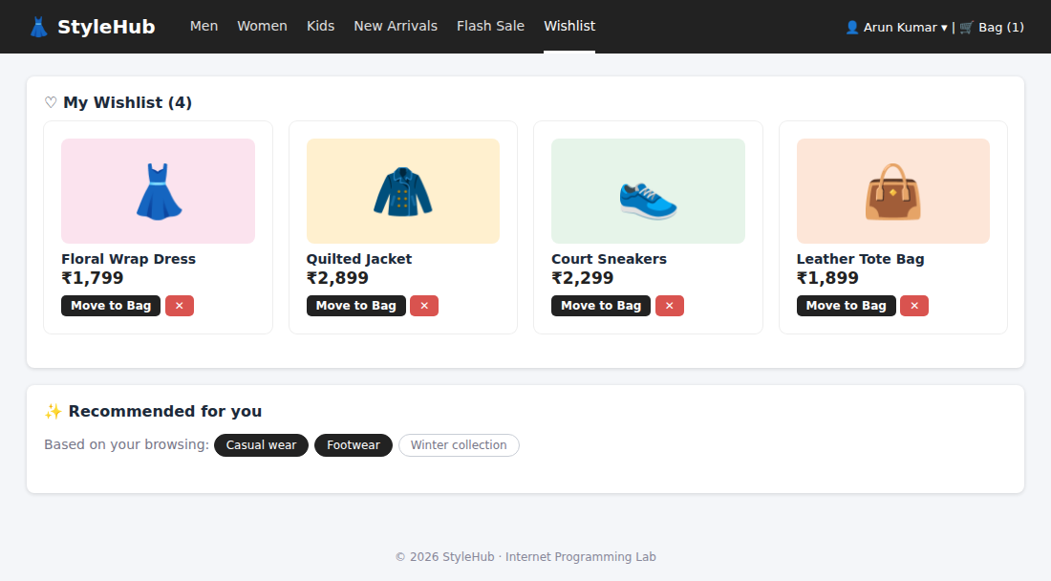
Figure 59: Wishlist and personalised recommendations
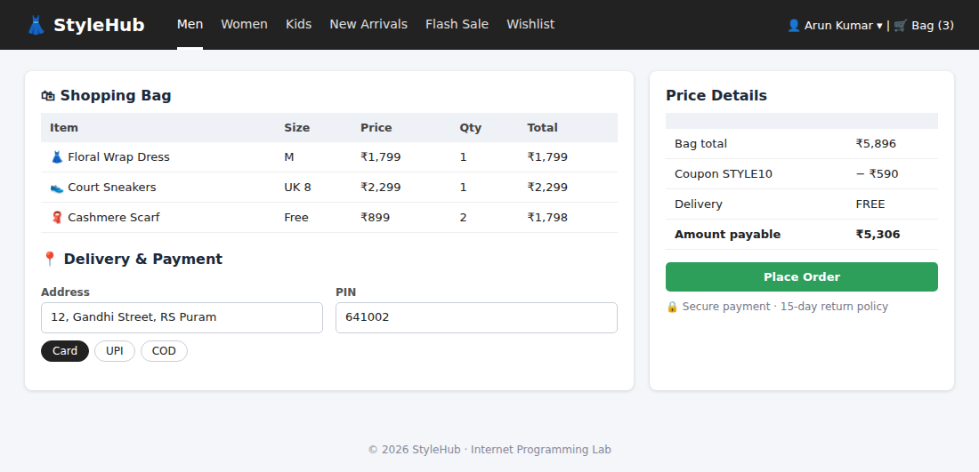
Figure 60: Shopping bag, checkout and payment
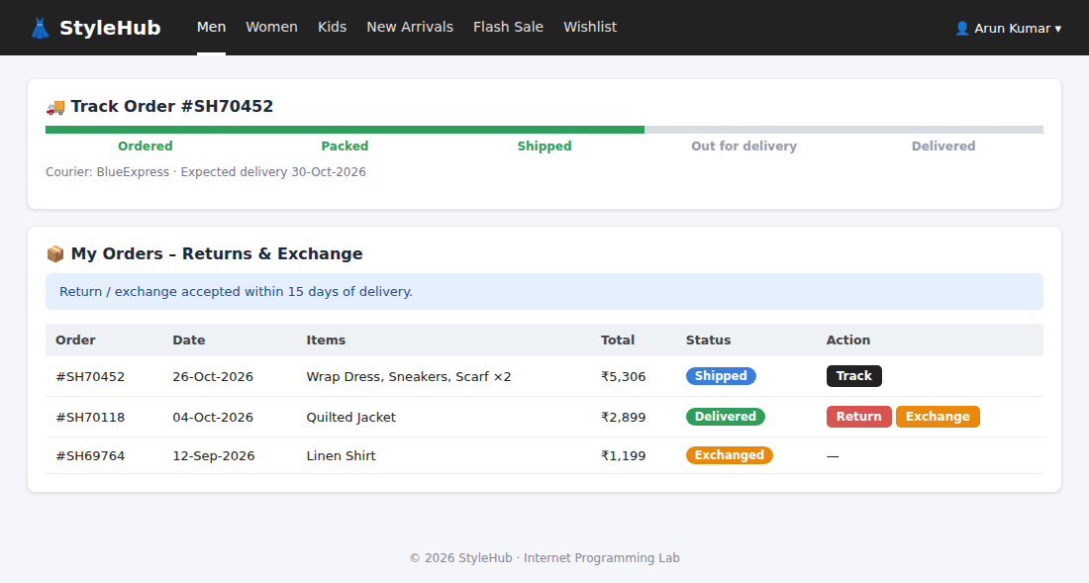
Figure 61: Order tracking, return and exchange

